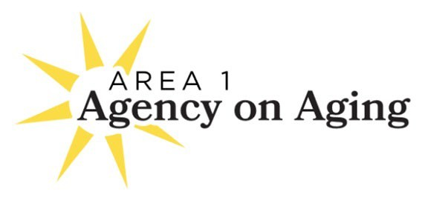

Notice of Meeting and Agenda
Area 1 Agency on Aging
Board of Directors Meeting
MEETING TO BE HELD VIA ZOOM

Tuesday, April 21, 2026, 2:30 pm - 4:00 pm
A1AA is inviting you to a scheduled Zoom meeting.
Join Zoom Meeting
https://zoom.us/j/98609123063?pwd=g75kcW5yaxNNjdVVU6Hd03RdihSGXK.1
Meeting ID: 986 0912 3063
Passcode: 040208

AGENDA | Page No.

CALL TO ORDER
- INTRODUCTIONS
- CONSENT AGENDA (ACTION) (5 minutes)
These matters are routine in nature and are usually approved by single vote. Prior to the meeting, any member of the public or Board may request the Board pull a particular item for further discussion.
  - Minutes
    - March 17, 2026, Board Meeting Minutes (attachment)…………………………………... 3
  - Director’s Report and Agency Happenings (Kraft) (attachments)
    - Director’s Report …………………………………………………………………………..5
    - Volunteer Expo Flyer………………………………………………………………………6
    - Del Norte - Humboldt Population Information 3.2026………………………….…………7
    - Certified Age Friendly Employer (CAFE), 2026 ………………………………………….9
  - Correspondence
    - Smullin 2026 Area Agency on Aging - Strategic Planning (attachment)………………….10
    - A1AA Assembly Budget Request - PSA 01………………………………………………..11
Recommendation: Approve Consent Agenda as presented.

- COMMITTEE REPORTS (60 MINUTES)

  - FINANCE, CONTRACT AND AUDIT COMMITTEE (Osborne-Stafsnes) (15 minutes)
    - Heather Roche-Waldo, Interim CFO Report to Board TIME SET 2:40 PM
    - March 2026 Edward Jones Statement and changes to investments. (attachment)………..13
    - Humboldt Area Foundation Quarterly Reports, March 31,2026 (attachments)…………..17
    - AAA-2425-01-A14 AP Budget Display (FRM2627-02) (attachment)……………...……19
    - Mileage Reimbursement Rate - 2026 rate is 72.5 cents per mile. We are currently at 70 cents.

Recommendation: Approve new 2026 rate for mileage reimbursement of 72.5 cents per mile, as of April 1, 2026, and increase the rate January 2027 to allowable mileage reimbursement rate.

  - EXECUTIVE COMMITTEE (Vogel) (10 minutes)
- Strategic Planning Document Discussion and Approval (attachment)…………………….20

Recommendation: Approve the Strategic Planning Document.

  - MEMBERSHIP/NOMINATING COMMITTEE (needs new chair).
- We now have Volunteer Jackets in all sizes for board members to pick up.

  - RESOURCE DEVELOPMENT COMMITTEE (Netjes) (15 minutes)
    - Calls to recent donors over $50.
    - Bold Day of Giving Fundraiser (attachment) (Roberts)………………………………….24
    - Art Sale – Delay until late summer
    - Young at Heart Event in October

- ADVISORY COUNCIL REPORT (Rose) (20 minutes)
- Report from Public Hearing
- Area Plan Presented for Board Approval (ACTION) (Separate Attachment)

Recommendation: Approve the Area Plan and direct staff to submit to CDA by May 1.

- BOARD and STAFF MEMBER COMMENTS

- ADJOURNMENT OF REGULAR BOARD MEETING

- PERSONNEL COMMITTEE CLOSED SESSION IF NEEDED

NEXT MEETING: MEETING May 19, 2026, 2:30 TO 4 PM Zoom Meeting

